Completa
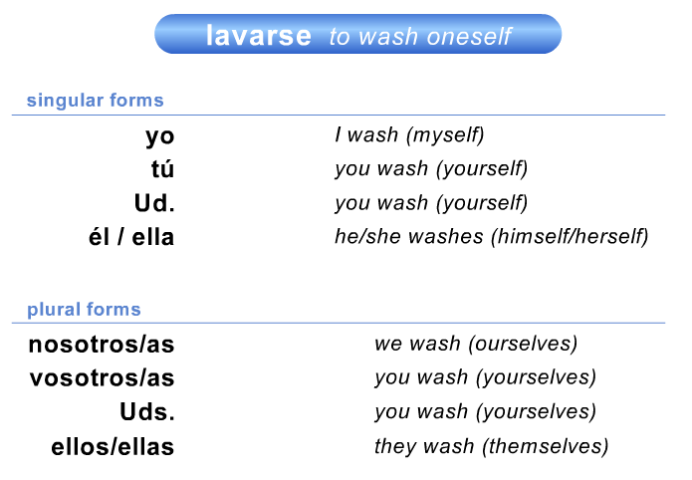
Traduce
You wake up at seven o’clock ______________________________________________________________________________________________________
I come my hair ______________________________________________________________________________________________________

Common reflexive verbs (escribe en español)
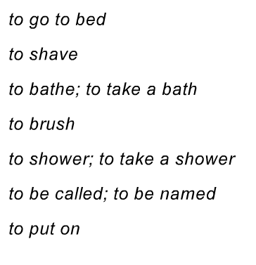
Traduce
They are going to get dressed ______________________________________________________________________________________________________
We are washing our hands ______________________________________________________________________________________________________

Compare and contrast
Traduce
Lola washes her face ______________________________________________________________________________________________________
The girl put on her socks ______________________________________________________________________________________________________
I need to brush my teeth ______________________________________________________________________________________________________

